Flume

1) Ejemplo 1: Spooldir

> vi spool-to-logger.properties

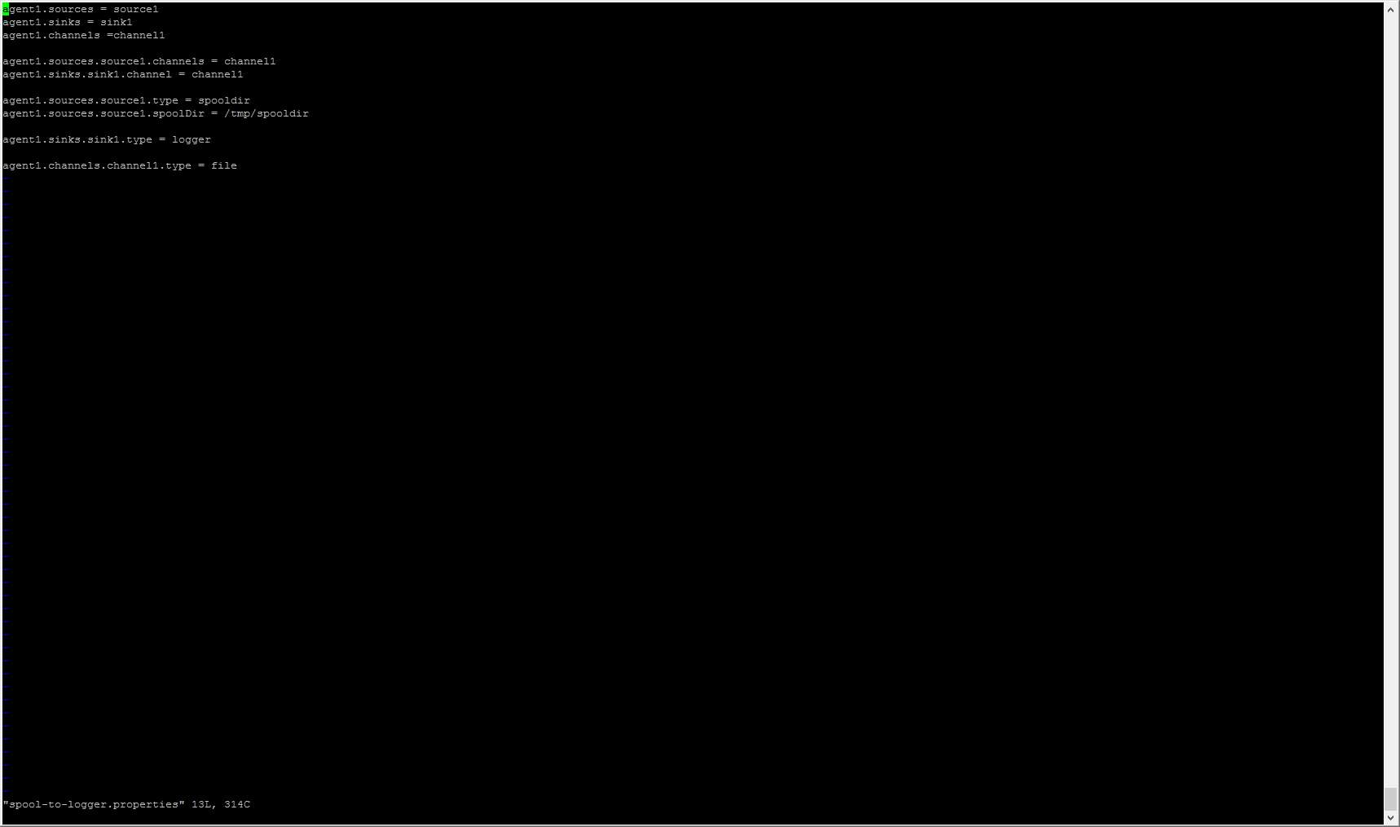

> mkdir /tmp/spooldir

> flume-ng agent --conf-file /etc/flume/conf/spool-to-logger.properties --name agent1 --conf /etc/flume/conf/ -Dflume.root.logger=INFO,console

> echo "CIFF Big Data" > /tmp/spooldir/.ciff1.txt

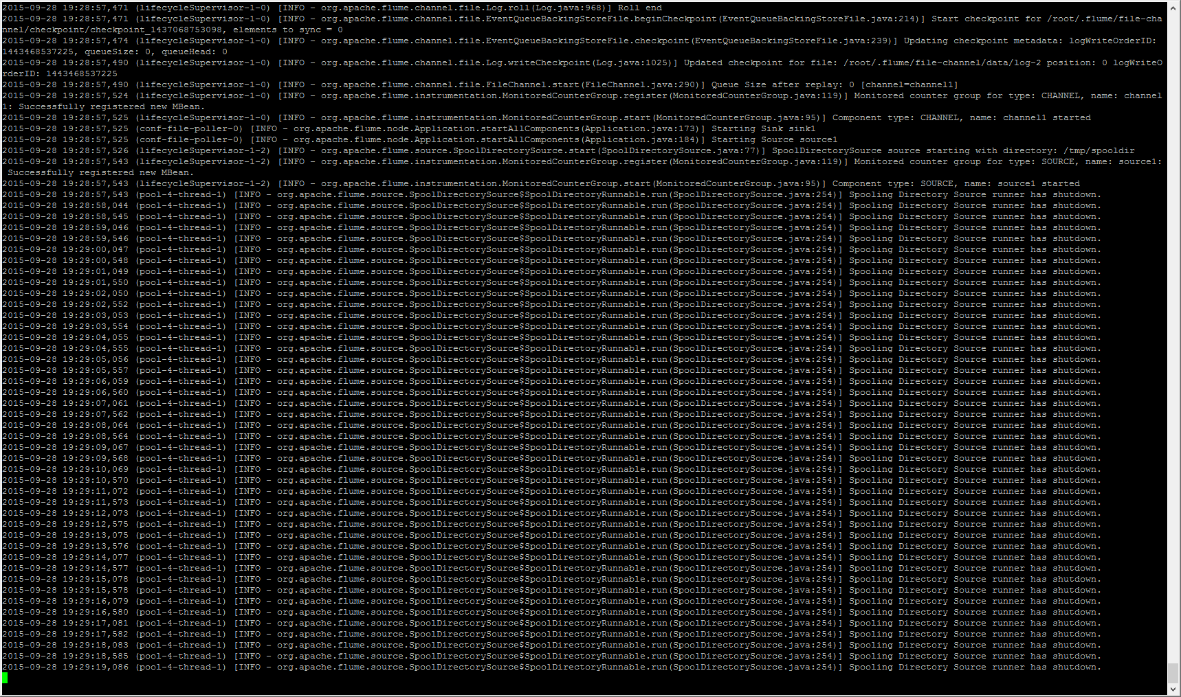

> mv /tmp/spooldir/.ciff1.txt /tmp/spooldir/ciff1.txt

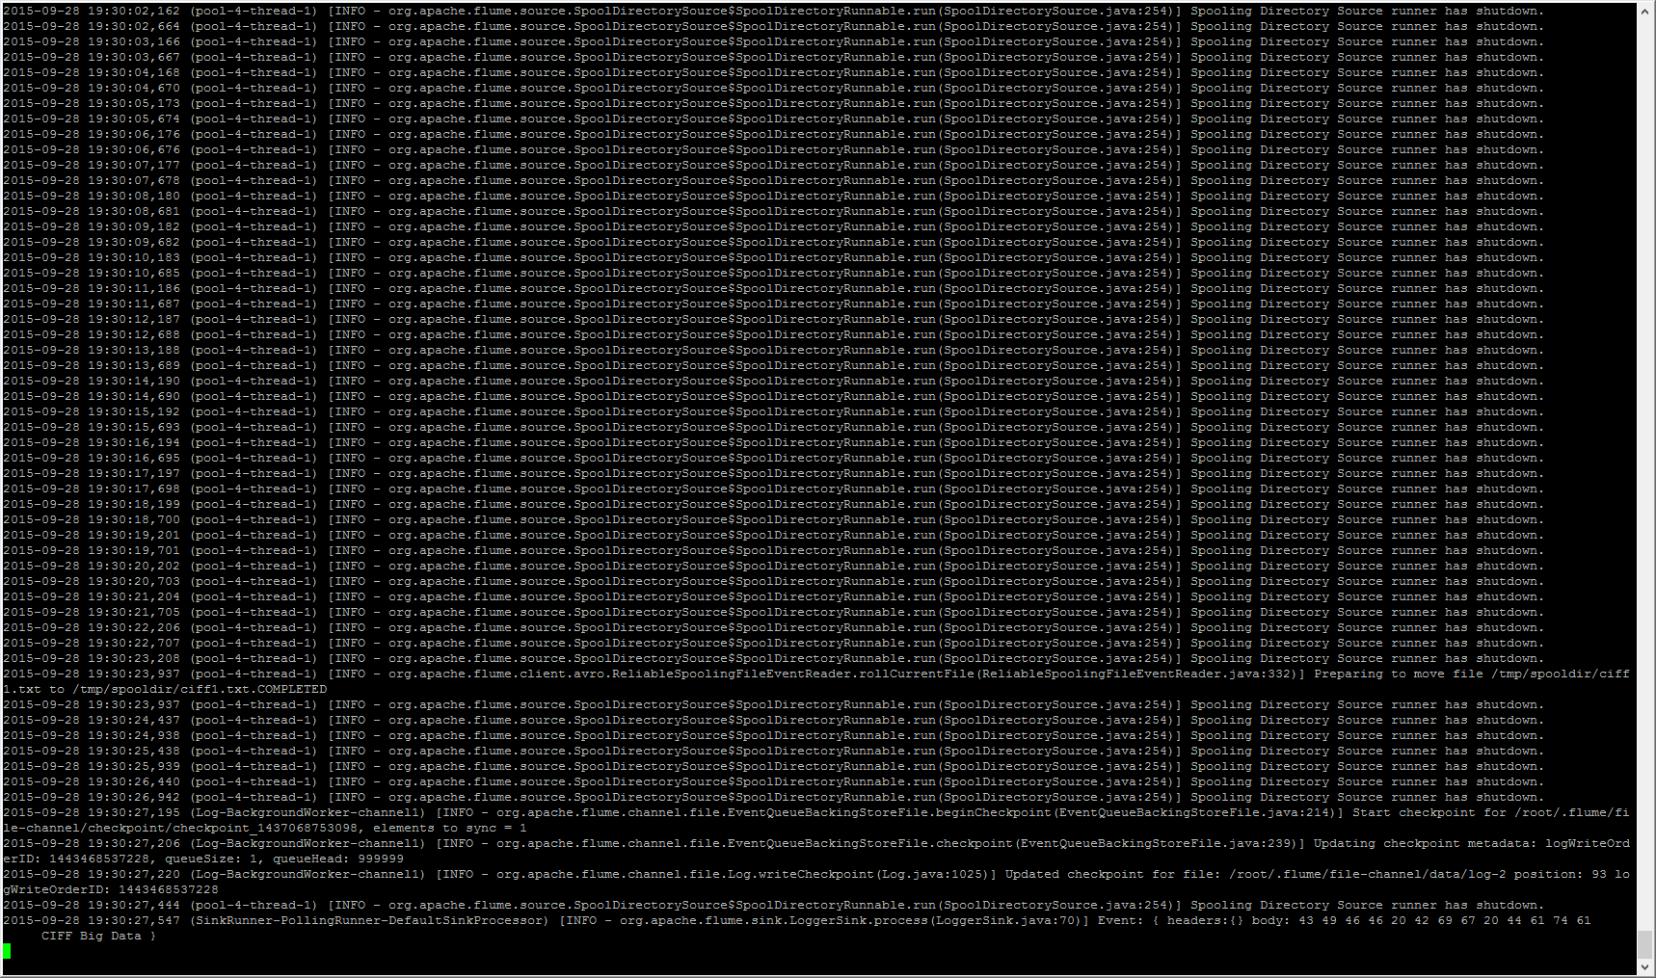

2) Ejemplo 2: HDFS Sink

> vi spool-to-hdfs.properties

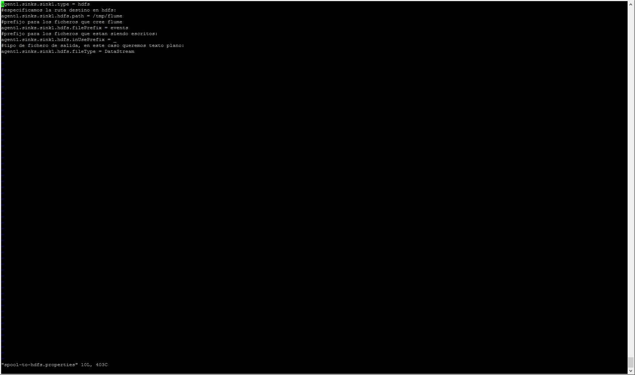

> flume-ng agent --conf-file /etc/flume/conf/spool-to-hdfs.properties --name agent1 --conf /etc/flume/conf/ -Dflume.root.logger=INFO,console

> echo "CIFF Big Data" > /tmp/spooldir/.file1.txt

> mv /tmp/spooldir/.file1.txt /tmp/spooldir/file1.txt

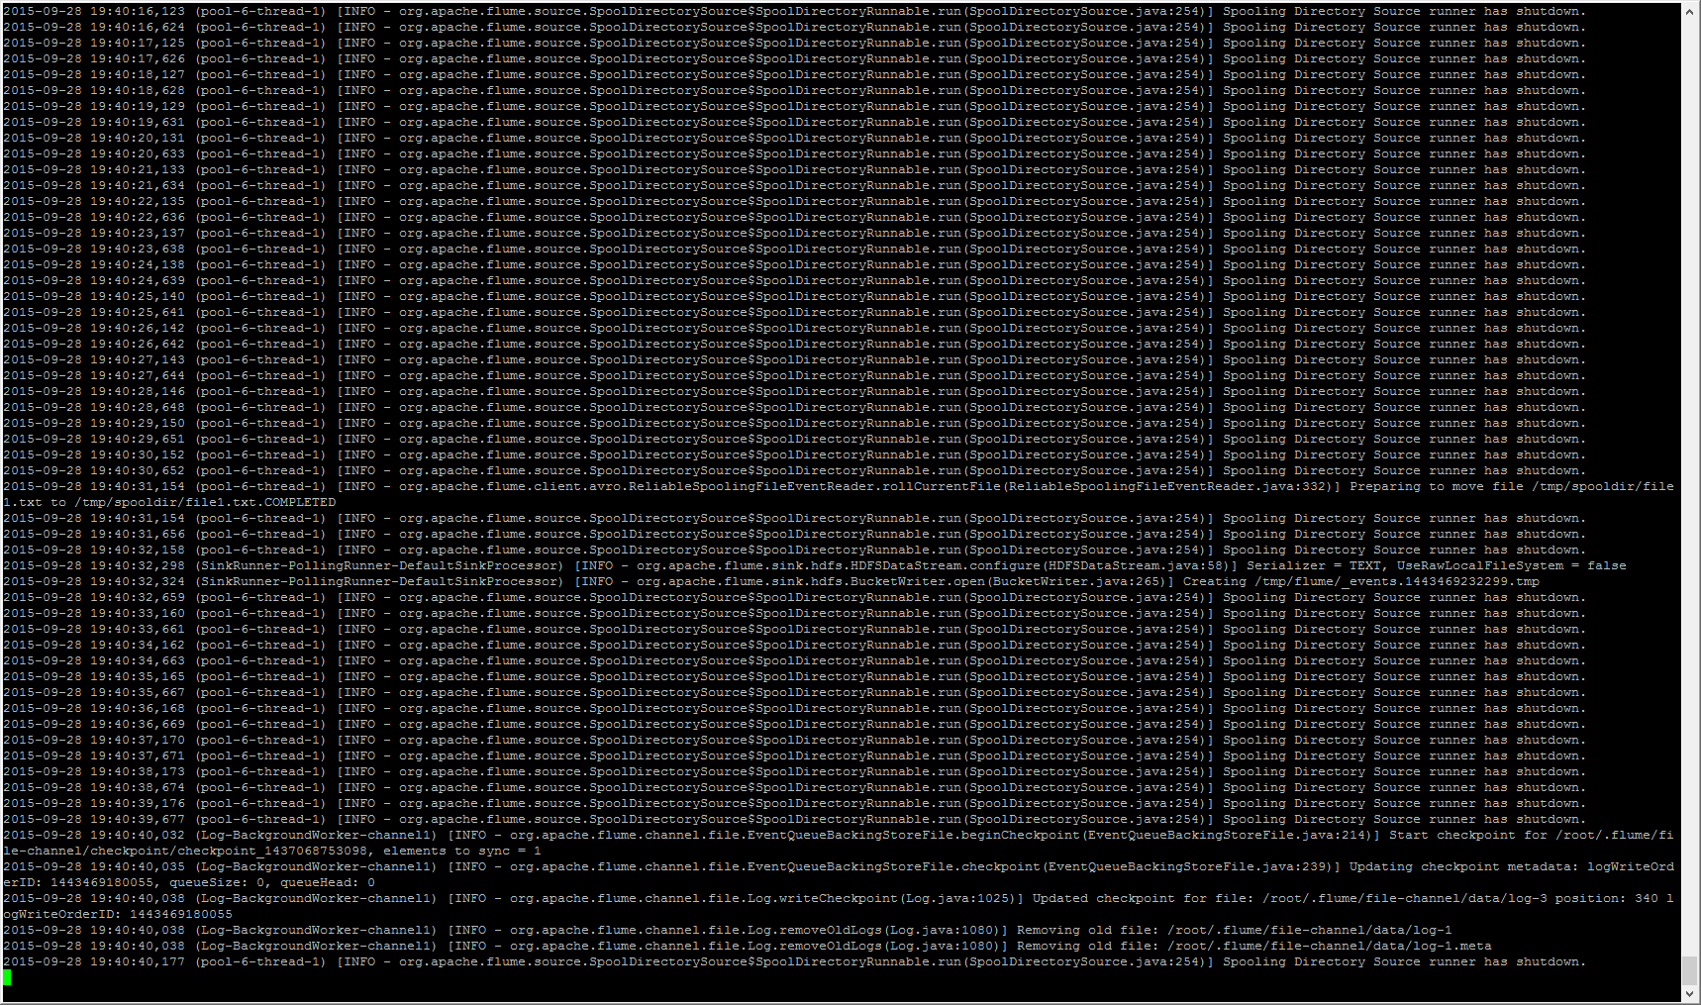

> hdfs dfs -text /tmp/flume/events.1443469232299

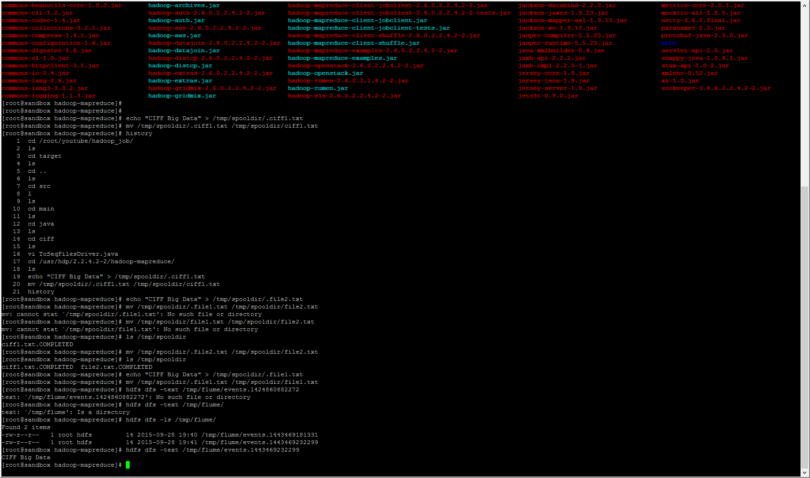

3) Ejemplo 3: Particionado

> vi spool-to-hdfs-partitioned.properties

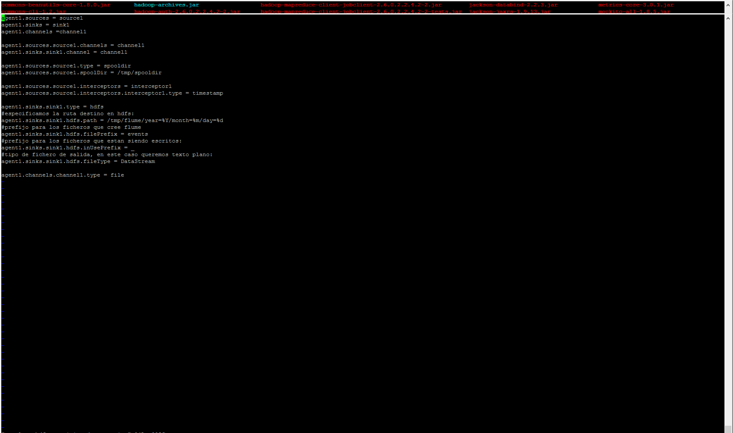

> flume-ng agent --conf-file /etc/flume/conf/spool-to-hdfs-partitioned.properties --name agent1 --conf /etc/flume/conf/ -Dflume.root.logger=INFO,console

> echo "CIFF Big Data" > /tmp/spooldir/.file2.txt

> mv /tmp/spooldir/.file2.txt /tmp/spooldir/file2.txt

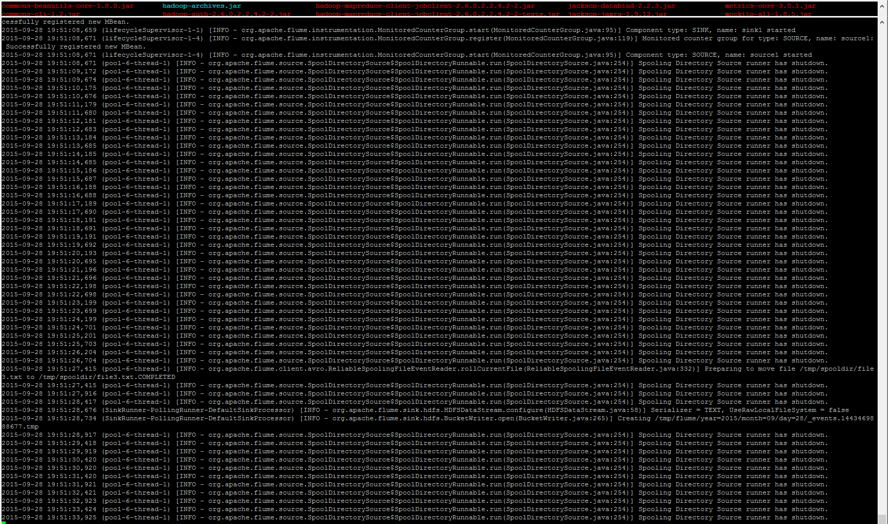

> hdfs dfs -ls -R /tmp/flume/

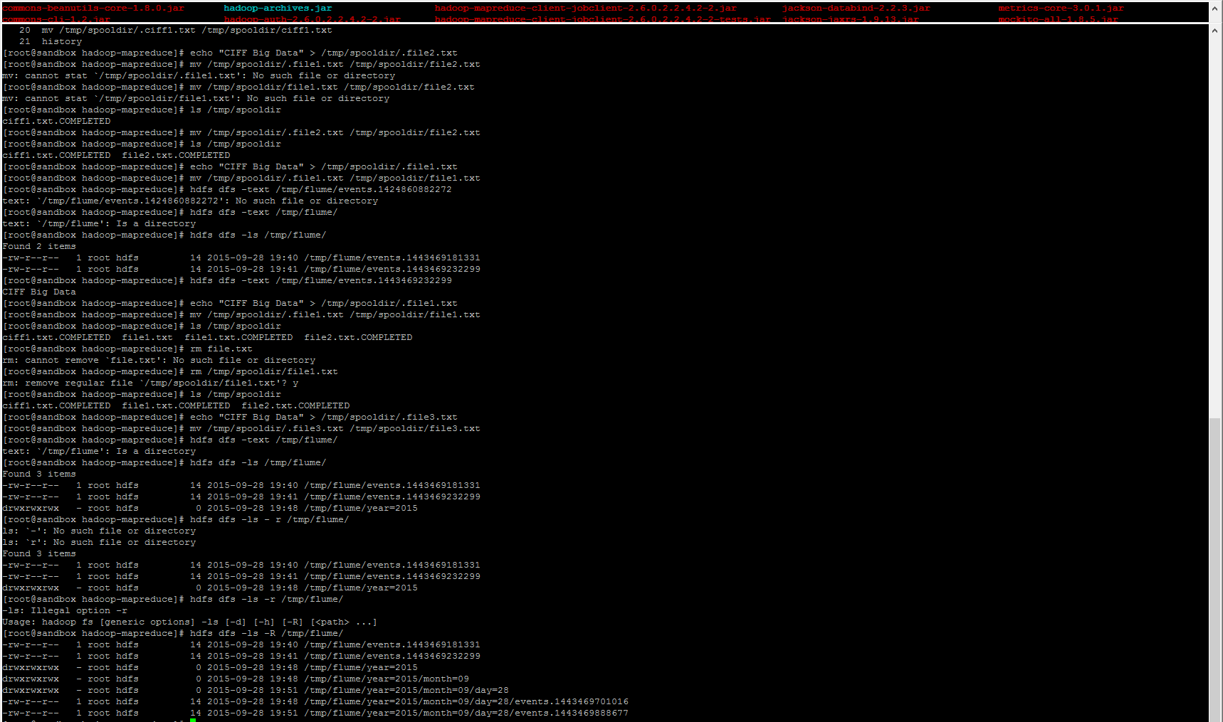

4) Ejemplo 4: Fan Out

> vi spool-fanout.properties

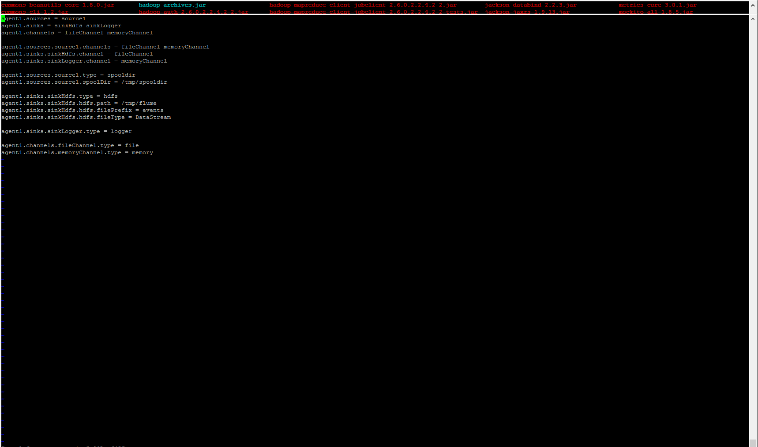

> flume-ng agent --conf-file /etc/flume/conf/spool-to-hdfs-partitioned.properties --name agent1 --conf /etc/flume/conf/ -Dflume.root.logger=INFO,console

> echo "CIFF Big Data" > /tmp/spooldir/.file4.txt

> mv /tmp/spooldir/.file4.txt /tmp/spooldir/file4.txt

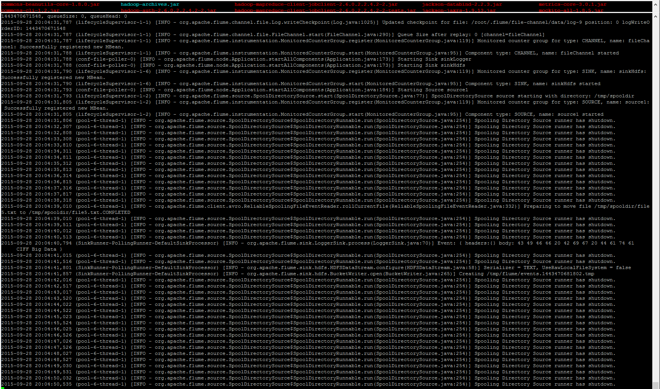

> hdfs dfs -text /tmp/flume/events.1443470525618

